Salaried GP
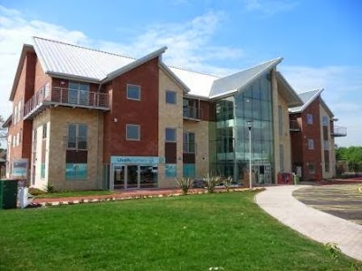

An exciting opportunity to join our friendly team at Churchfields has arisen due to the relocation of one of our team.

Churchfields is a large busy teaching practice in the centre of Bromsgrove located in a purpose-built modern building. We are a multi-disciplinary team consisting of doctors, physician associates, clinical pharmacists, nurses, health care assistants supported by receptionists, secretaries and admin staff. We are also joined by GP trainees and medical students from the University of Birmingham.

We are rated good by the CQC.

We support the development of special interests and currently our salaried doctors and physician associates join us in providing ear suction services, minor ops and joint injections.We are looking for an enthusiastic, hardworking doctor to join us for 6-8 sessions in continuing to provide great care for our patients well into the future.

We welcome informal visits. Please send your cv and covering letter to our practice manager Mrs Clare Sewell - Clare.sewell@nhs.net

Closing date 11/9/26

